
Dear Counselor/Billing Contact:
We are sending this letter on behalf of our mutual client, J.B. Hunt Transport, Inc. As you know, J.B. Hunt Transport, Inc. is transitioning to the LexisNexis® CounselLink application for the receipt, processing, and approval of your invoices.
Please complete the steps outlined below as soon as possible, as all invoices will need to be submitted through CounselLink as of August 30th, 2021.
Let’s get started! Please complete the following tasks:
- Register*
- Add Timekeepers
- Enter rates
- Acknowledge Billing Guidelines
REGISTER
Please go to www.counsellink.net and click the 'Sign Up' link.
- Click the following link to view the CounselLink Law Firm User Guide
*If your firm is already registered with CounselLink, there is no need to re-register. You can simply log on to your CounselLink account and add any timekeepers that bill J.B. Hunt Transport, Inc. to your office profile and then enter their rates using fee structure ID 8832 (hourly) and/or 8833 (flat rate).
ADD TIMEKEEPERS
From the Home page, click the link under Offices:
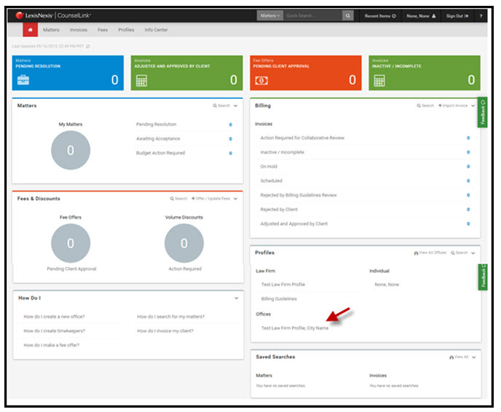
- Go to the Office Staff section and review timekeepers
- If you need to add billers, click Add User and complete one screen per timekeeper
- Repeat until all timekeepers are entered
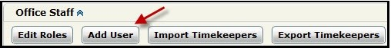
ENTER RATES
Once your firm is associated with your client, their name will display in the client drop down in the upper left corner of your CounselLink Home page
Click the Fees tab. If your firm bills J.B. Hunt hourly, use fee structure ID 8832. If you bill J.B. Hunt a flat rate, please use fee structure 8833. Click here for instructions to enter rates
Negotiated Discounts: For firms with whom J.B. Hunt Transport, Inc. has negotiated discounts, the discount must be present on the fee offer. Click HERE for instructions to add a discount to your fee offer.
ACKNOWLEDGE BILLING GUIDELINES
J.B. Hunt Transport, Inc. has developed Outside Counsel Billing Guidelines and request you review carefully and incorporate these billing guidelines into your billing practices.
To acknowledge the guidelines:
- Click the blue Billing Guidelines link at the top of the sent fee offer
  - You may also access this document by going to the InfoCenter tab and click Billing Guidelines
- Add a check mark in the acknowledgement box
- Click 'Accept'
TRAINING
LexisNexis provides FREE on-line training through the LexisNexis University, which is available at your convenience. A link to access training is provided on the CounselLink Home page. Click HERE for details
This will complete the registration requirements. J.B. Hunt Transport, Inc. must complete the following steps before you can submit invoicing. They are:
- Review and approve the fee offer
- Assign matters to your CounselLink account
BUDGETS
Upon receipt of your matter assignments, J.B. Hunt Transport, Inc. may require that some or all matters have a budget of fees and expenses expected for the life of the matter be submitted and approved by them prior to invoicing. Please see the CounselLink Law Firm User Guide for Instructions to Create a Budget.
For invoicing assistance, please contact ask@lexisnexis.com or dial 800-600-2282.
We look forward to your registration with the CounselLink application.
Sincerely,

Keith Bruni
Specialist, Attorney Implementation, CounselLink
LexisNexis Legal & Professional

Attorney Implementation Team-CounselLink
attorneyimplementation@lexisnexis.com

Free 24x7 Customer Support
800-600-2282
+1 919.378.2713
ask@lexisnexis.com

CONFIDENTIAL - PRIVILEGED INFORMATION
This e-mail may include confidential, trade secret or legally privileged information. If you are not the intended recipient, please do not read, copy, use, distribute or disclose this communication to anyone other than the intended recipient. Please notify the sender of any error in transmission or delivery and delete any misdirected e-mail from your system.

