A picture containing clipart

Description generated with high confidence

**State Ordering Reference Guide**

**Mar 4, 2024**

Table of Contents

Introduction 2

Florida 2

Subpoena – Unique to Workflow in Florida 2

Subpoena – Unique to Ordering in Florida 2

Texas 3

Subpoena - Unique to Setup in Texas 3

Subpoena – Unique to Ordering in Texas 3

Washington 4

Stipulations with Authorization 4

# Introduction

Welcome to Ontellus! This guide will provide you with directions to help you with state specific variances that you will need to know when placing orders on the My.Ontellus.com portal.

# Florida

Florida has some unique process with record retrieval requests. Review the below for an overview.

## Subpoena – Unique to Workflow in Florida

*Last Updated: 2/12/24*

**Florida** is unique to the subpoena workflow process due to having to **e-file**.

* **Ontellus** creates all legal paperwork and sends to the client.
* **Client (Law Firm)** e-files Notice of Production from Non-Party and provides to Ontellus. Send this to [Order.Processing@Ontellus.com](mailto:Order.Processing@Ontellus.com). Documents received prior to 2pm ET will be noticed same day, after 2pm ET will be next day.
* **Ontellus** to send the notice packet to Opposing Counsel and others provided on service list via e-service email provided.
* **Client (Law Firm)** e-files Subpoena and Certificate of Non-Objection and provides to Ontellus. Send this to [Order.Processing@Ontellus.com](mailto:Order.Processing@Ontellus.com) (documents received prior to 2pm ET will be noticed same day, after 2pm ET will be next day).
* **Ontellus** serves custodian and proceeds to obtain records.

## Subpoena – Unique to Ordering in Florida

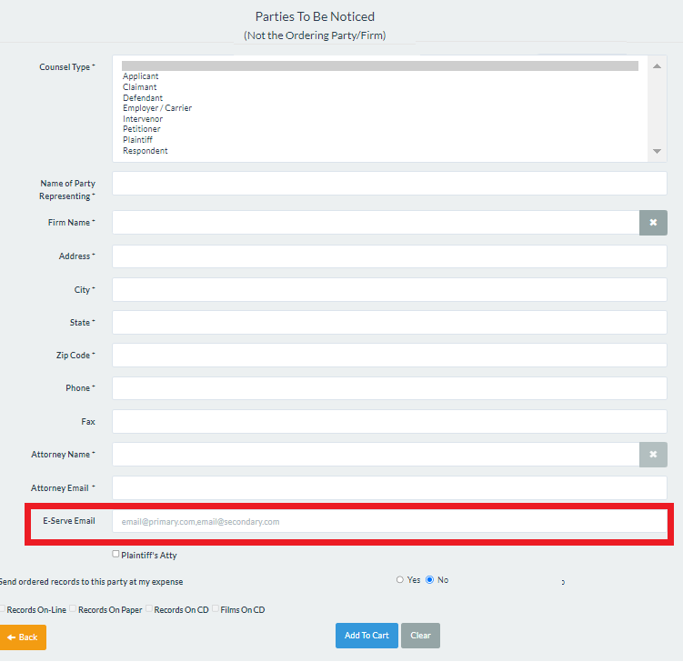*Last Updated: 2/12/24*

When placing the order, the following will need to be included:

When placing the order, the e**-Service e-mail** for all parties i.e. Opposing Counsel, Co-Counsel, Requesting Attorney will need to be added.

**My.Ontellus Portal:**

* E-Service email should be listed in the ‘**Parties to Be Noticed**’ section on the order form.

# Texas

Texas has some unique processes with record retrieval requests. Review the below for an overview.

## Subpoena - Unique to Setup in Texas

*Last Updated: 2/12/24*

Texas is unique to the subpoena workflow process due to having multiple options with the legal documents. The firms can be set up with the following process in place:

* **Deposition Upon Written Questions (DWQ)** *– this is set up as a firm wide preference*
  + Admissible DWQ - *set as default
  + Admissible DWQ with Affidavit
  + Non-Admissible DWQ
  + Non-Admissible DWQ with Affidavit
* **Paid vs Incurred DWQ** – set as default for Billing Records

Once the firms preferences are set, this will be how all orders will be processed moving forward.

## Subpoena – Unique to Ordering in Texas

*Last Updated: 2/12/24*

Texas is unique in how counsel will be noticed. Ontellus will notice counsel via Texas e-File Portal.

When placing the order, the e**-Service e-mail** for all parties i.e. Opposing Counsel, Co-Counsel, Requesting Attorney will need to be added.

**My.Ontellus Portal:**

* E-Service email should be listed in the ‘**Parties to Be Noticed**’ section on the order form.

# Washington

Washington has some unique process with record retrieval requests. Review the below for an overview.

## Authorization with Stipulation – Unique to Workflow in Washington

*Last Updated: 2/12/24*

Authorization with stipulation is the most common way to obtain records for our clients in Washington State.

Ontellus does not draft the stipulations, they are provided by the clients with signatures form all parties on the case.

Ontellus will send copies of the authorizations and stipulations to all counsels (if listed on the Parties to be Noticed section) as well as the Custodian.

## Authorization with Stipulation– Unique to Ordering in Washington

*Last Updated: 2/12/24*

When placing the order for a Stipulation, place the order as an **Authorization/Stipulation** request. On the Document Upload tab select the Document Type as “Authorization”.

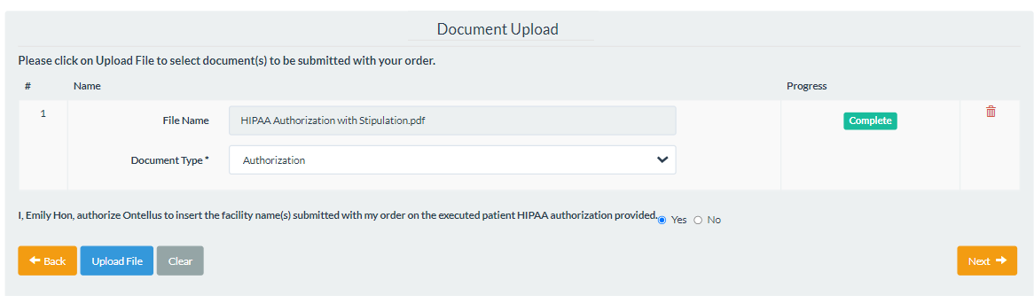

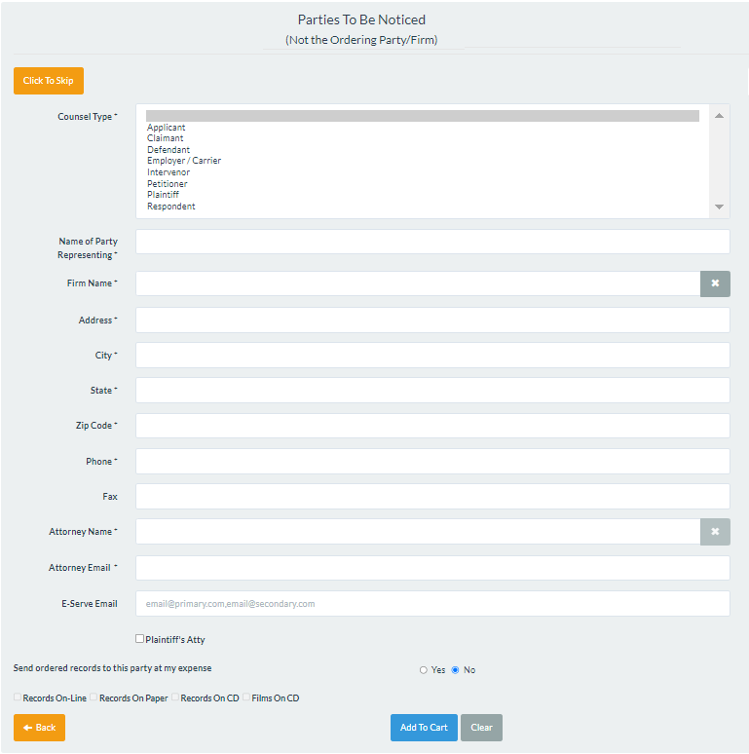

If parties need to receive a copy of records, add all respective parties to the ‘Parties To Be Noticed’ section on the order form and select the that you want Ontellus to send a copy of the records and how to produce.