Lexis® Learn │ Getting Started

Lexis® Learn is an online learning platform that includes interactive video tutorials on legal research skills.

STUDENT ENROLLMENT INSTRUCTIONS

* A picture containing meter

  Description automatically generatedSign in to [www.lexisnexis.com/lawschool](http://www.lexisnexis.com/lawschool) and   
  click on **Lexis Learn**, at the top of your screen

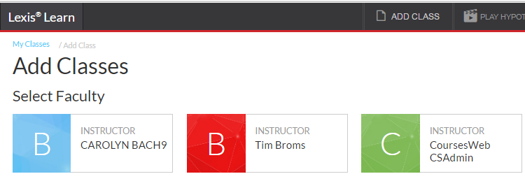

* Click ADD CLASS (top right), and then select your Professor’s name in the alphabetized listing

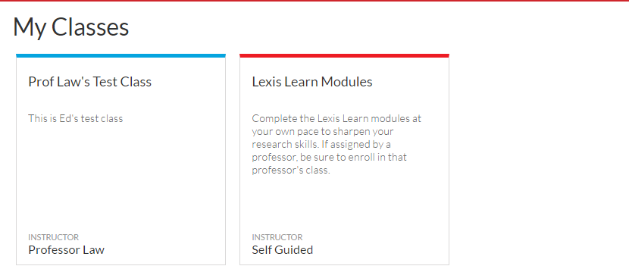

* Select your Professor’s class

* You are now enrolled in your Professor’s class and can access the modules assigned.

SUPPORT OPTIONS

* **Help** button in Lexis Learn
* Contact your [LexisNexis Representative](http://www.lexisnexis.com/en-us/lawschool/portal/contact-rep.page), contact infoat [lexisnexis.com/lawschool](http://www.lexisnexis.com/lawschool)
* 24/7 LexisNexis® Customer Support: 1-800-45-LEXIS (800-455-3947)